Etsyscrape package

“Etsy is the global marketplace for unique and creative goods. It’s home to a universe of special, extraordinary items, from unique handcrafted pieces to vintage treasures.” – Etsy.com

This package allows the user to scrape and explore the information returned by an Etsy search.

When viewing data from an Etsy.com search results list you may want to explore the data more in-depth. This package allows the user to scrape data from an Etsy.com search for further analysis.

Extracts data from Etsy.com search results via web-scraping. This package has a number of functions suited to this purpose.

* etsyURL
* etsyXML
* etsyItemResults
* etsyItemLinks
* etsyShopResults
* etsyShopLocations
* etsyShopReviews

This document introduces you to etsyscrape’s basic set of tools and shows you how to apply them to scraped html data from Etsy online search results.

Scraping search data: etsyURL and etsyXML

The etsyURL and etsyXML functions allow the user to scrape the results of an Etsy.com search.

In the example below, the shopper is searching Etsy.com for “Christmas socks”. Etsy.com returns the following page to the shopper’s screen:

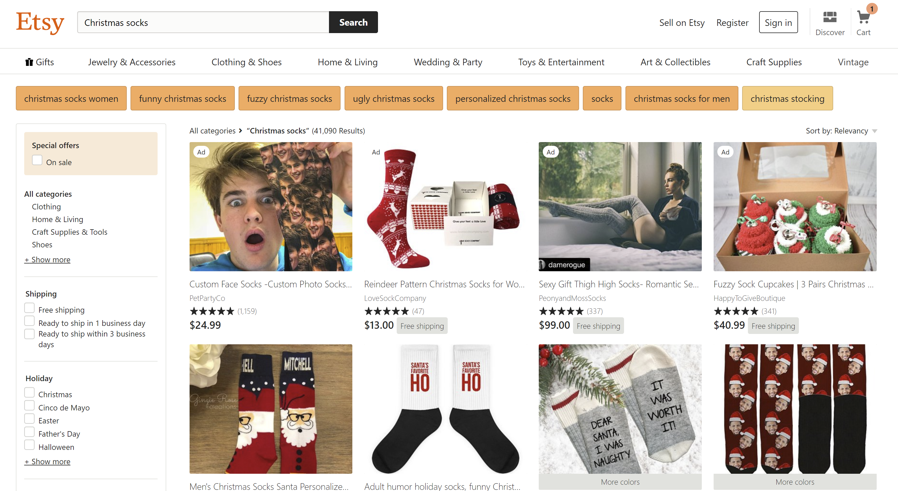

The etsyURL function creates this URL without having to visit Etsy.com directly.

Instead of visiting Etsy.com, the user simply enters their search string in the etsyURL() function. Here the URL for this search is saved as socks_url.

{r socks_url <- etsyURL(“christmas socks”)

socks_url}

The etsyURL function returns the URL associated with the search results (the URL that would lead to the webpage displayed in the image).

The etsyXML function scrapes the html of the Etsy.com search results, using a URL. In this example, we use the URL created above, for the “Christmas socks” Etsy.com search. Here the scraped html is stored as the variable “results”

{ r results <- etsyXML(socks_url)}

**Extracting information from search data: etsyItem* and etsyShop* functions**

etsyItemResults

etsyItemLinks

etsyShopResults